# EXAMPLE CHARTS

## Buy’s

**Heikin Ashi-MACD:**

Heiken Ashi-Stochastic-RSI-MACD:

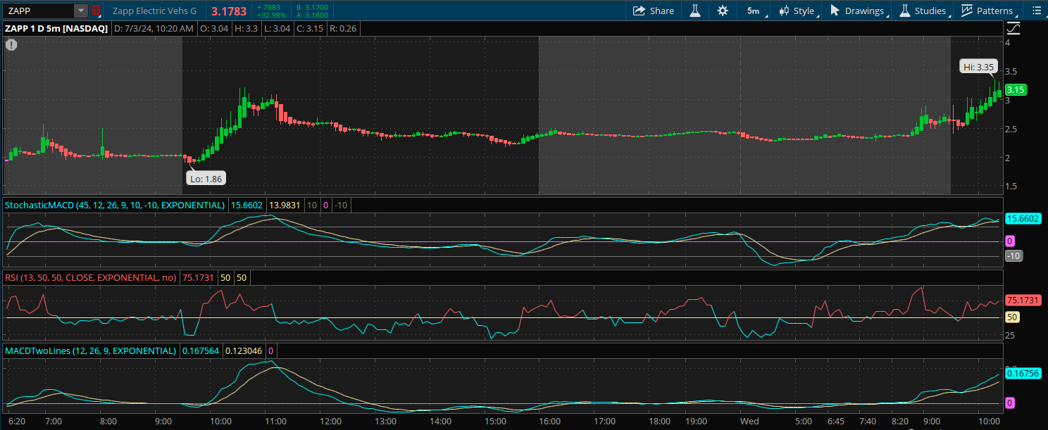

## **Sell’s**

## **Patterns**

